M.L.PARMAR COLLEGE OF COMPUTER SCIENCE & IT

PROJECT REPORT
BACHELOR OF COMPUTER
APPLICATION
(B.C.A 6 TH SEMESTER)
YEAR: 2025-26

PNP Sales Analysis

Guided By: Submitted By:
Guide Name: Student Name:
Prof. Nidhi Naik Tapaniya Parth Chimanbhai.
Tapneeya Neekunj Arvindbhai
Tarsariya Prince Chandubhai
ACKNOWLEDGEMENT

I would like to express my special thanks of gratitude to my project guide prof. Nidhi Naik as well as our principal Hiral Meswania to do this wonderful project which helped us in doing a lot of research and we came to know about so many new things, we are really thank full to them.
Secondly I would also like to thanks my friends who helped me a lot in finishing this project within the limited time.

INDEX

Sr. No | Title | Page No
1. | Introduction | 4
2. | Description | 5
3. | Analysis and Outputs | 7
4. | Observations | 18
5. | Conclusion | 19
6. | Tools & Technologies Used | 20

- Introduction

Data analytics is the process of examining raw data to extract meaningful insights, patterns, and trends. It helps organizations make informed decisions and improve performance.
In this project, we analyze a sales dataset downloaded from Kaggle. The objective is to understand customer behavior, product performance, and sales trends using Python libraries such as Pandas, NumPy, Matplotlib, and Seaborn.

This project focuses on:
Customer demographics analysis
Sales performance evaluation
Identifying high-performing products
Understanding purchasing patterns

2. Description

The dataset contains 11,251 records and 15 columns. It represents customer purchase data including personal details, product information, and transaction values.

Columns in Dataset:
User_ID → Unique ID of customer
Cust_name → Customer name
Product_ID → Unique product ID
Gender → Male/Female
Age Group → Age category
Age → Customer age
Marital_Status → Married/Unmarried
State → Customer state
Zone → Region of customer
Occupation → Customer profession
Product_Category → Type of product
Orders → Number of ordersAmount → Total purchase amount
Status → (Mostly empty / irrelevant)
unnamed1 → Empty column (to be removed)
Data Cleaning Steps:
Removed unnecessary columns (Status, unnamed1)
Handled missing values
Converted data types where required
Checked duplicates

3.Analysis and Outputs

1.Gender-Based Analysis.

Female customers contribute more to total sales.
Women tend to shop more frequently than men.

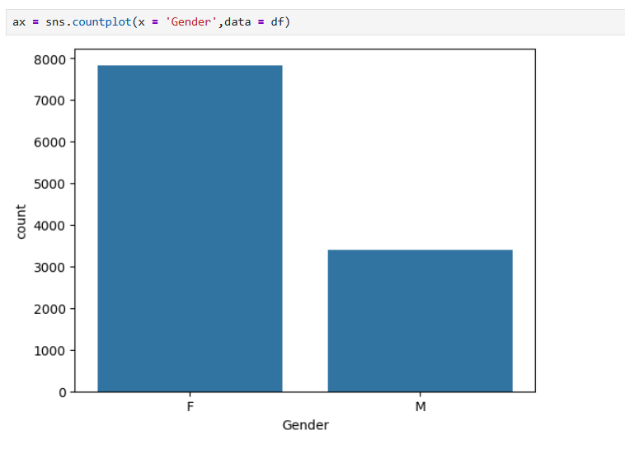

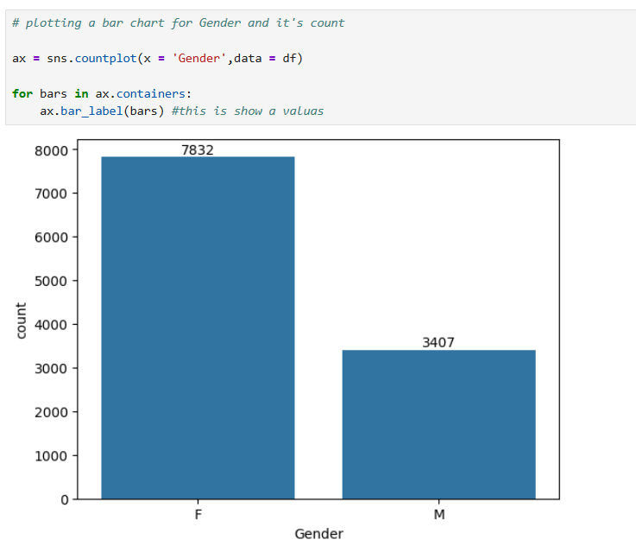

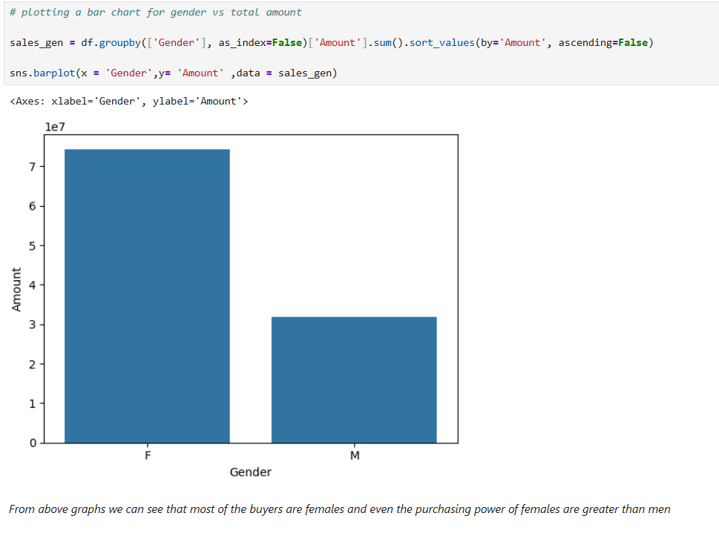
2. Age Group Analysis

Highest sales come from the 26–35 age group.
Young adults are the primary buyers.

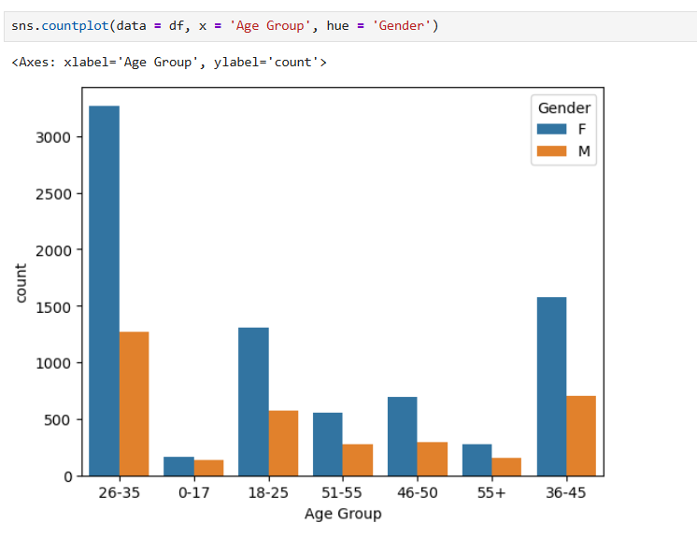
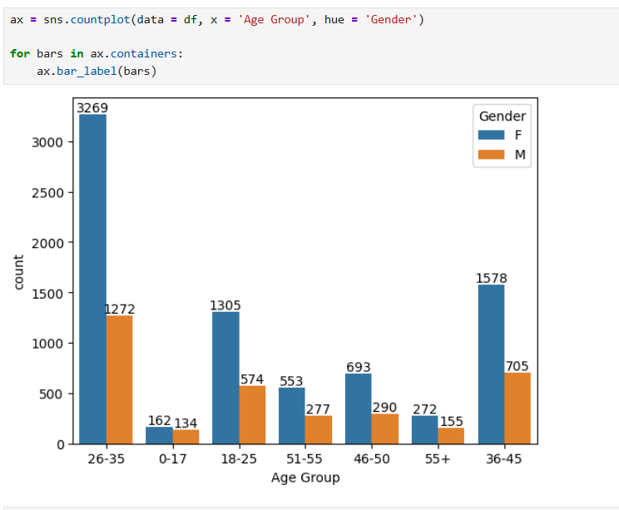
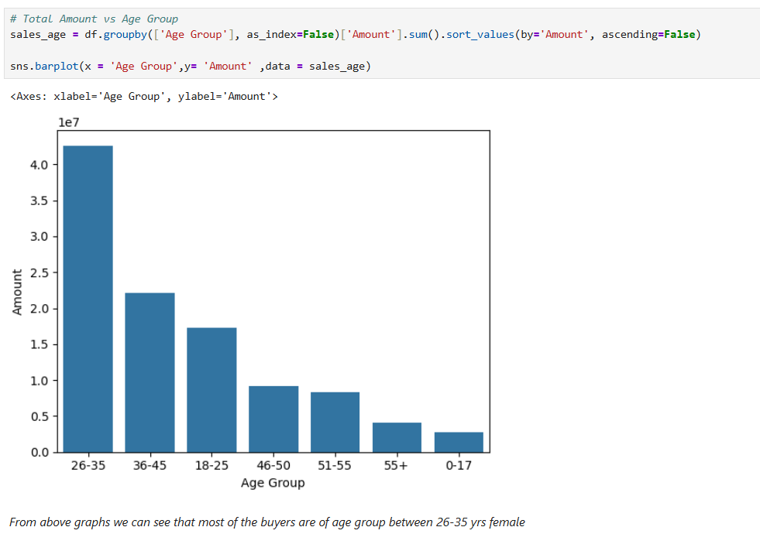
3. State-wise Sales
Top contributing states:
Uttar Pradesh
Maharashtra
Karnataka

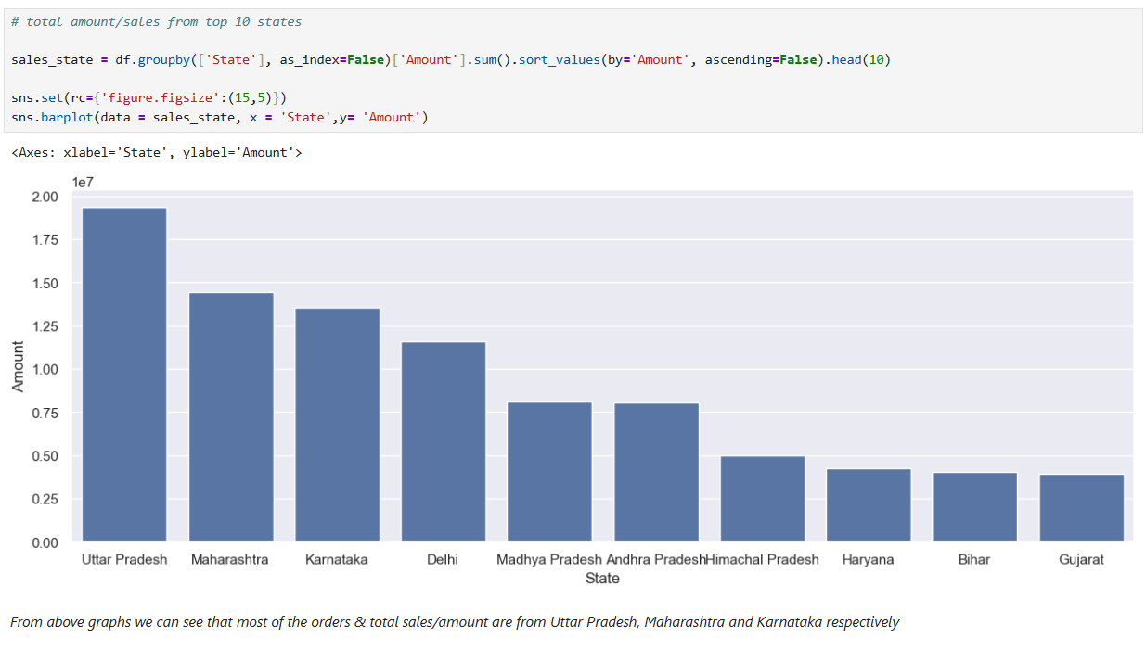

4. Marital Status Analysis
Married customers show higher purchasing power.
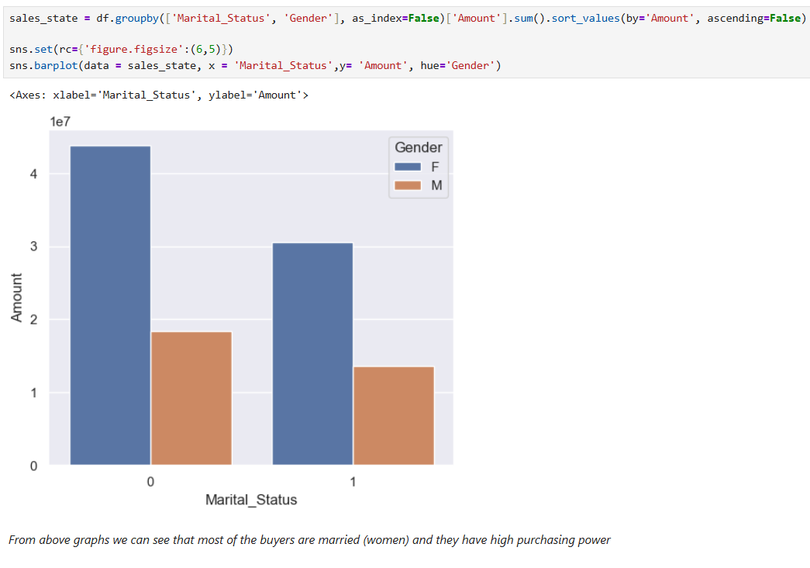
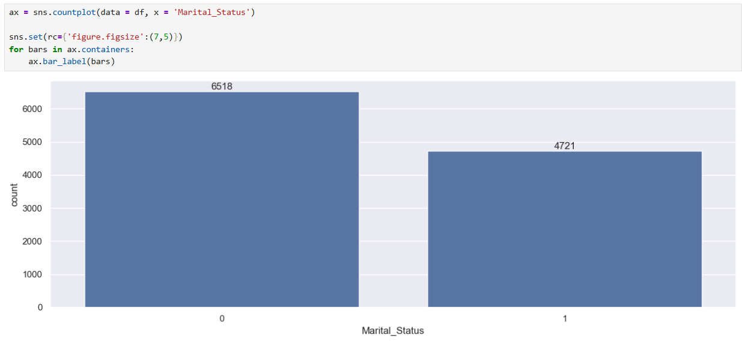
5. Occupation Analysis
Highest sales from:
IT sector
Healthcare
Aviation
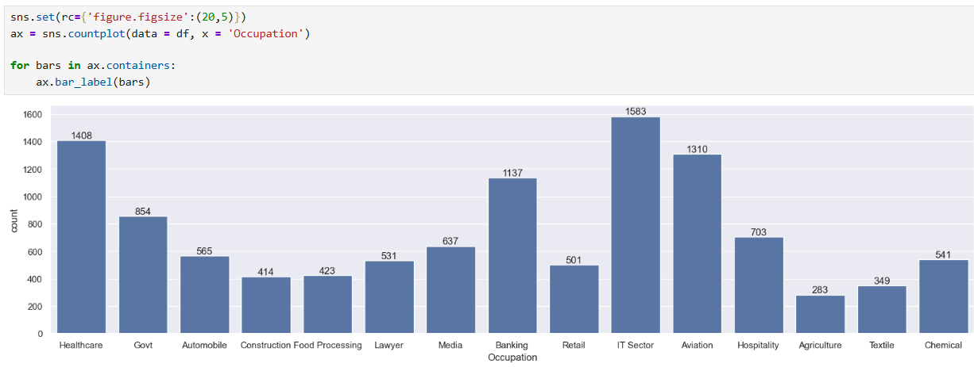
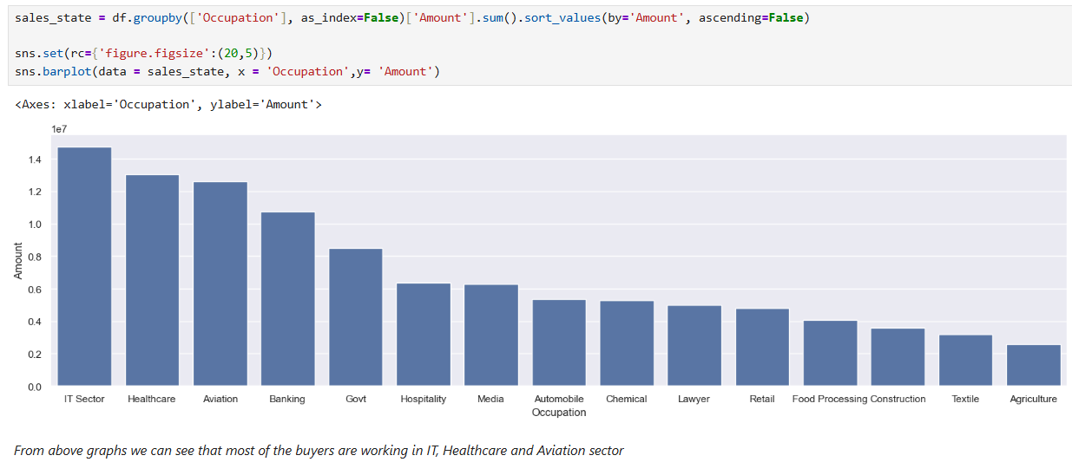
6. Product Category Analysis
Most popular categories:
Clothing & Apparel
Electronics
Food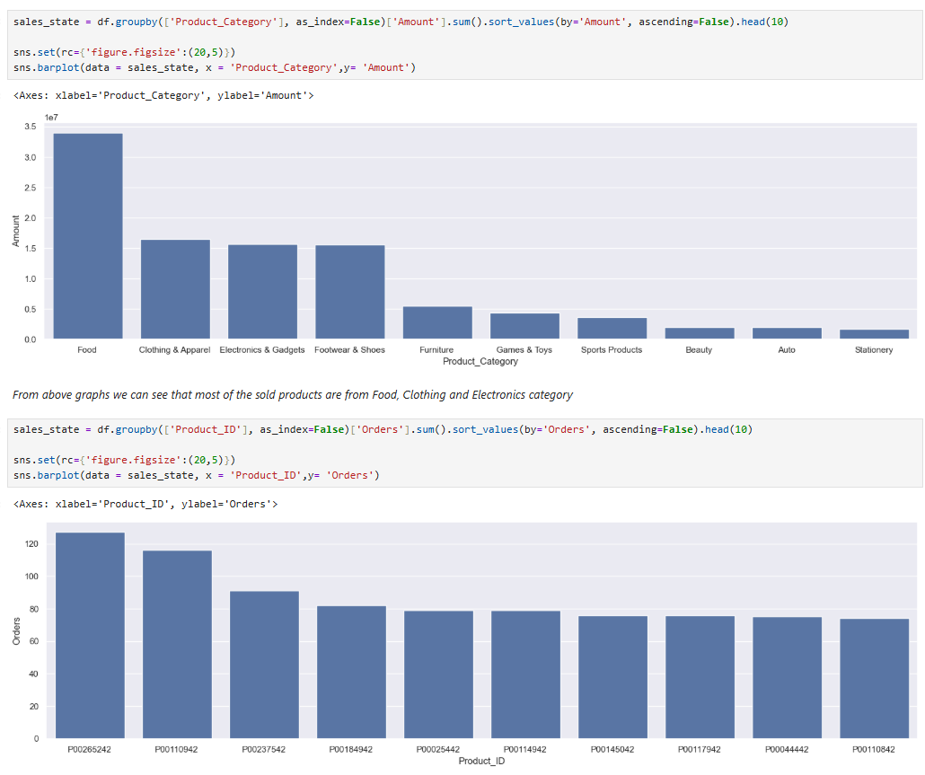
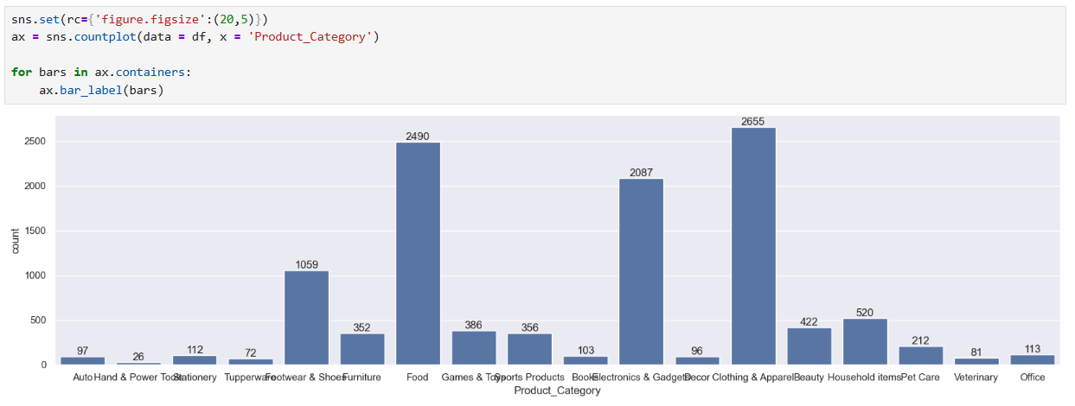

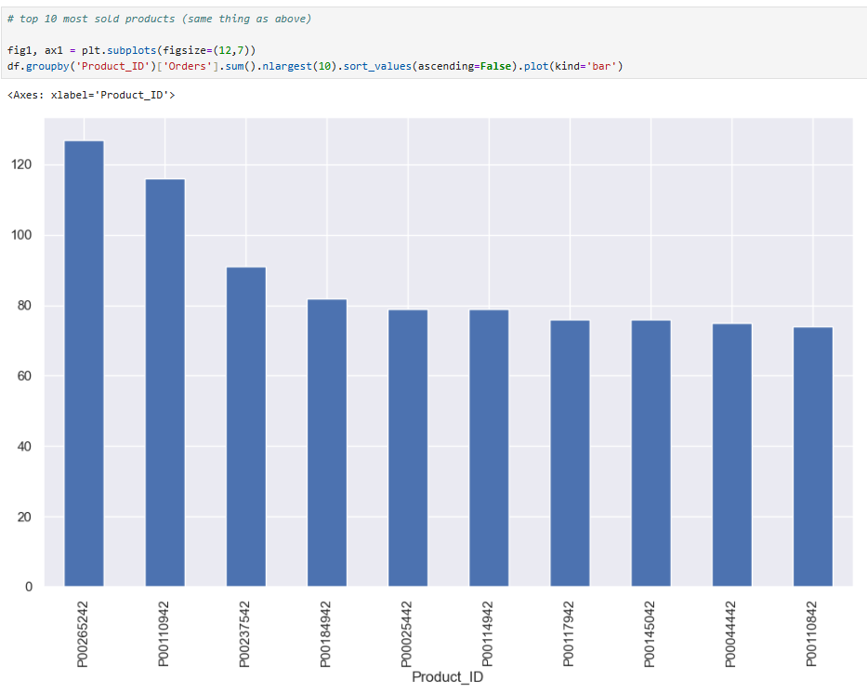
7. Orders vs Amount
Higher number of orders directly increases total sales amount.
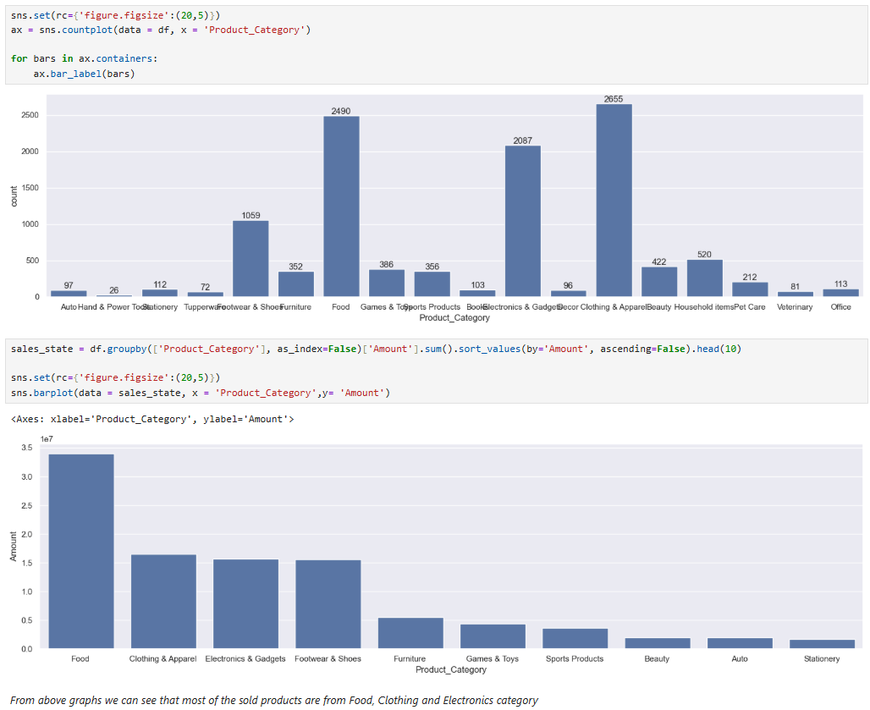
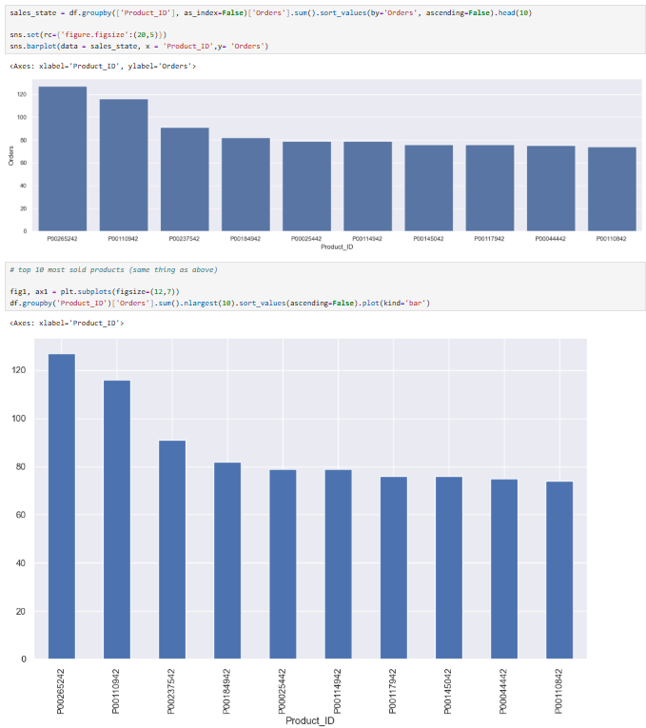

4. Observations

Female customers are the major buyers in the dataset.
Age group 26–35 dominates purchasing activity.
Married individuals spend more compared to unmarried ones.
Certain states contribute significantly to overall revenue.
Product categories like clothing and electronics are highly demanded.
Occupation plays an important role in purchasing capacity.

5. Conclusion

This analysis provides valuable insights into customer behavior and sales patterns. Businesses can use this data to:

Target female customers more effectively
Focus marketing on the 26–35 age group
Increase inventory for high-demand product categories
Expand operations in high-performing states
Customize offers based on occupation and marital status

Overall, data analytics helps transform raw data into actionable insights, improving business decisions and increasing profitability.

6. Tools & Technologies Used
Python
Pandas
NumPy
Matplotlib
Seaborn
Jupyter Notebook

